**

**Useful Websites**

**Henry County Public Schools**

<http://schoolwires.henry.k12.ga.us/site/default.aspx?PageID=1>

**Fairview Elementary School**

<http://schoolwires.henry.k12.ga.us/fe>

**My School Webpage**

<http://schoolwires.henry.k12.ga.us/Domain/8212>

**Infinite Campus Parent Portal**

<https://campus.henry.k12.ga.us/K12_Custom/cparent/index.jsp?appName=henry&version=1&rel=hhchk>

**Google Classroom**

<https://support.google.com/edu/classroom/answer/6020279?hl=en>

**Classdojo**

[www.classdojo.com](http://www.classdojo.com)

*“My goal this year is to not only get your child ready for the next grade, but the grades to come by teaching and learning from them to the best of my ability. With your child’s eagerness to learn and your support, we can have a successful and fun year. Let’s make this a great year of learning the standards and learning from each other. Remember our school theme:* ***“As a Fairview Family, We are Better Together”***



*Greetings! On behalf of the Fairview Elementary School Faculty & Staff, I would like to welcome you to the 2019-2020 school year. It is my sincere hope that you have a wonderful year and that you obtain all of the knowledge that you can stand!*



458 Fairview Road

Stockbridge, Georgia 30281  
  
**Phone:** 770-474-8265  
**Fax:** 770-474-5528

**Dr.Benjamin** **Mr. Mincey**

*Principal*  *Assistant Principal*

## Welcome!

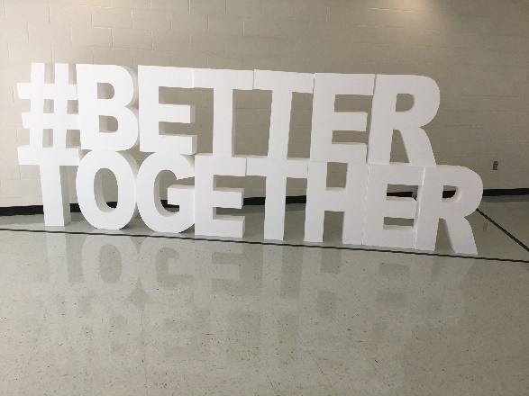

**“As a Fairview Family, We are Better Together”**

**Mrs. S. Pittman, M.S.**

Bachelors of Science in Early Childhood Education

Masters of Science in Instructional Technology

ESOL Certified

Gifted Certified

[shoni.pittman@henry.k12.ga.us](mailto:shoni.pittman@henry.k12.ga.us)

to

Gifted @ Fairview



**This year, we will be utilizing flexible/alternative seating…**

**What is flexible seating?**

It is the first step towards independent learning; rather than being told what to do, or in this case where to sit, children have the opportunity to be given a choice. This allows for them to solve problems and become more proactive learners as they age but also leads way to better collaboration, communication, creativity and critical thinking skills.

**What research supports flexible seating?**

Brain research also confirms that physical activity – moving, stretching, and walking – can actually enhance the learning process. Eric Jensen (2000), in his article *Moving with the Brain in Mind,*protests against the sedentary classroom style and suggests a better way to spend the long days in our classrooms, not only for students, but for teachers. Teachers need to engage students in a greater variety of postures, including walking, lying down, moving, learning against a wall or desk, perching, or even squatting. The brain learns best and retains most when the organism is actively involved in physical activity.

**What are the benefits of flexible seating?**

**1. Better health**

Reduced risk of disease

Less stress

Strengthened mental health

Improved physical fitness

2. **Effective learning**

Better cognitive performance

Higher ability to concentrate

Improved memory retention

Higher academic achievement

3**. Improved behavior**

Students are less disruptive

Students are better able to focus on the tasks they were assigned

Fewer disciplinary incidents are reported

Excess energy is used up

**5th year as Fairview Faculty Member**

*15th year of teaching*

**Alumnus of Mercer University &**

**Troy State University**

*Bachelor’s Degree in Early Childhood Education*

**Master’s Degree in Instructional Technology**

**Married for 11 years**

9 year old son, 8 year old daughter

**Love to eat**

*LOVE TECHNOLOGY!*

Behavior Management & Communication

This year, I will be using Class Dojo. Class Dojo is a web-based program that allows students to receive points for positive behavior. Class Dojo will only be used for the students, the daily behavior sheet will be for you to reference how your child’s day went. I will also use Class Dojo as a communication tool. Information will be sent home at the start of class.



# ★About the Teacher ★

Important

Information

* I play instrumental or classical music throughout the day to provide the students with a calm learning environment.
* The class and I will construct our classroom expectations. The rules will be on my webpage and be displayed in the classroom.
* Your child’s work and important information pertaining to gifted will be sent home daily/weekly in their binder. Please discuss your child’s work with them and keep at home.
* The students will utilize their supplies from their homeroom classes. If anything else is needed, I will notify you in a timely manner.
* The students will be receiving rigorous projects and curriculum based instruction in all subject areas. *Projects will be sent home to complete as well.*
* We will be also be attending field trips with your permission of course ☺
* Google Classroom, which is an online collaboration and work space will be utilized. More information will be sent home at the start of class.



